|  |  |
| --- | --- |
| **Databases**  Diploma in IT / FI / CSF  Year 1 (2019/20) Semester 2 | Week **3** |
| **2** hours |
| **PRACTICAL 3**  **SELECT (Part 3)** | |

**OBJECTIVES**

At the end of this practical, you should know how to:

* construct SQL queries that use Scalar and Aggregate Functions

**REFERENCES**

Please refer to the following:

* Appendix B in Database textbook: Tables in *NP40 Book Rental System*’s Database
* Appendix E in Database textbook: Data Dictionary for *NP40 Book Rental System*
* Database Text book: pages 2-23 to 2-42
* PolyMall: Database Systems - Topic 1 Basic Select

[1.6 How to sort the rows](https://polymall.polytechnic.edu.sg/webapps/scor-scormengine-BB5784d4c32fccb/delivery?action=launchPackage&course_id=_813_1&content_id=_30615_1)

* PolyMall: Database Systems - Topic 2 Functions

[2.1 Using Functions - String Function](https://polymall.polytechnic.edu.sg/webapps/scor-scormengine-BB5784d4c32fccb/delivery?action=launchPackage&course_id=_813_1&content_id=_30622_1)

[2.2 Using Functions - Mathematical Function](https://polymall.polytechnic.edu.sg/webapps/scor-scormengine-BB5784d4c32fccb/delivery?action=launchPackage&course_id=_813_1&content_id=_36371_1)

[2.3 Using Functions - Date-Time Function](https://polymall.polytechnic.edu.sg/webapps/scor-scormengine-BB5784d4c32fccb/delivery?action=launchPackage&course_id=_813_1&content_id=_30624_1)

[2.4 Using Functions - Aggregate Function](https://polymall.polytechnic.edu.sg/webapps/scor-scormengine-BB5784d4c32fccb/delivery?action=launchPackage&course_id=_813_1&content_id=_36372_1)

**QUESTIONS**

Syntax:

**SELECT [ ALL | DISTINCT ] { \***

**| { table_name | table_alias }.\***

**| { column_name | express } [ [ AS ] column_alias ]**

**| column_alias = expression**

**} [ , … n ]**

**FROM table_name [ [ AS ] table_alias ]**

**[ WHERE search_condition ]**

**[ ORDER BY { order_expression [ ASC | DESC ] } [ , … n ] ]**

Construct SQL statements for the following queries.

### **Scalar Functions**

1. Execute the following SQL statements and observe the results:
   * 1. select GETDATE()
     2. select DATEPART(month, GETDATE())
     3. select DATENAME(month, GETDATE())

Notice the results generated for (b) and (c). The first parameter for the Scalar functions *DATEPART()* and *DATENAME()* should be a system defined value like *year*, *month*, *day* and others. The second parameter accepts a date component. Do find out more information on *DATEPART()* and *DATENAME()* on the Database textbook, page 2-30 and 2-31.

From your observations,

* + 1. write a sql statement to retrieve the year component of the current date

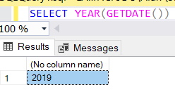

* + 1. write a sql statement to retrieve the day component of the current date

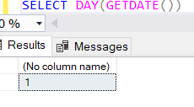

1. List the **'Years of Membership'** for each member with *NP40 Book Rental*. Display the results in the following format, in ascending order of **'Years of Membership'**:

MemberID Name DateJoin Years of Membership

………….. …….. ………… ……………………….

**Hint: use DATEDIFF(), GETDATE() to compute the years of membership DATEDIFF (year/month/day, StartDate, EndDate)**

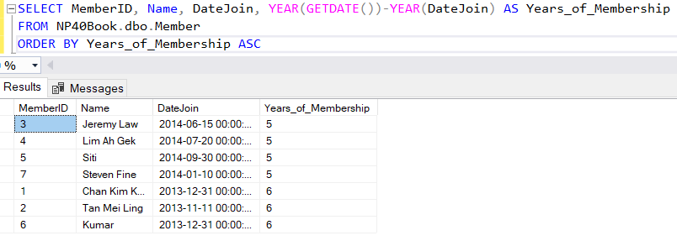

1. List the LoanNo, ISBN, CopyNo, MemberID and **'Number of Days Overdue'** for loans that are returned after the due date. Display the results in descending order of **'Number of Days Overdue'**.

**Hint: use DATEDIFF()**

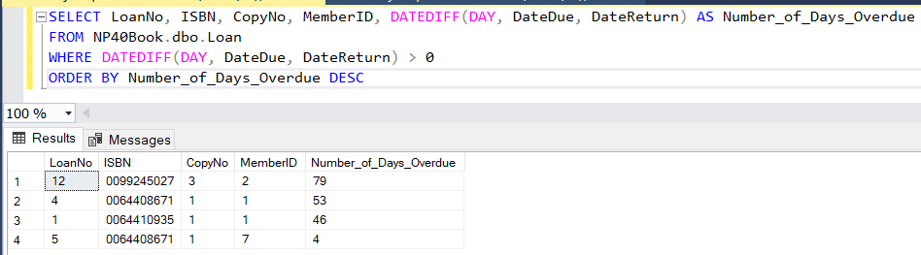4. List the StaffID, Name, Gender and Date of Birth (DOB) of staff whose Date of Birth falls in the month of February and display the results in ascending order of Name.

**Hint: use either DATEPART() or DATENAME()**

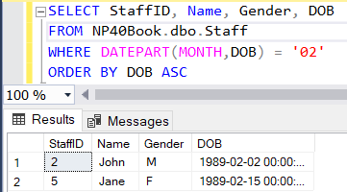

### **Aggregate Functions**

5. Find out the **‘Number of Staff’** in *NP40 Book Rental*.

**Hint: use COUNT Aggregate Function**

**Note: * in COUNT(*) represents all columns in the table**

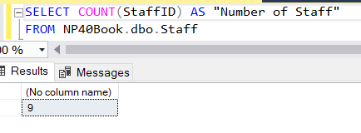

6. Find out the number of staff who has a supervisor.

**Hint: return the number of rows that has a value for the *SupervisorID* column**

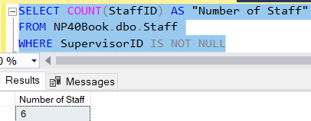

7. Find out the number of staff who are supervisors.

**Hint: use the DISTINCT keyword**

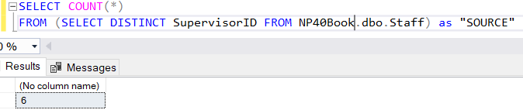

8. Find out the number of members who provided email address.

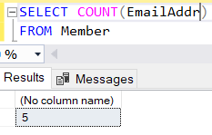

9. Find out the number of members who had not provided *NP40 Book Store* with their email addresses.

**Hint: use the WHERE clause and COUNT(*) Function**

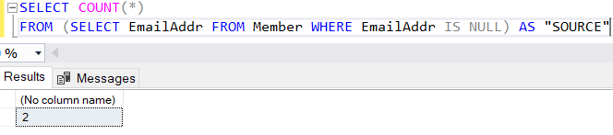

Compare and contrast the query statements for Q8 and Q9. Why is there a need to use a WHERE clause in Q9 but not in Q8.

* Cause you need to have a condition (NULL) for Q9 but Q8 no need

10. Find out the minimum RentalRate in *NP40 Book Store*.

**Hint: use MIN Aggregate Function**

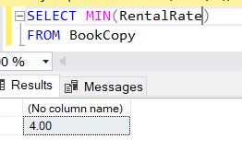

1. Display the total **‘Number of Loan’** and the **‘Total Rental Income’** for the year 2014.

**Hint: use COUNT, SUM Aggregate Function and DATEPART() / DATENAME()**

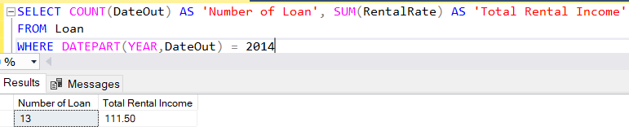

1. Display the total **‘Number of Staff’** and the **‘Total Annual Salary Payout’**.

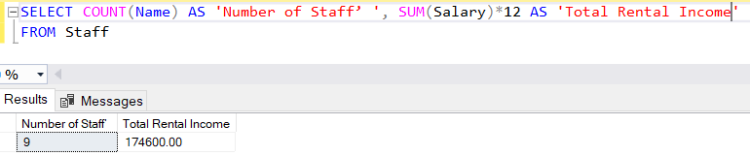

13. List all the loans with the revised DateDue by adding 10 days to their current DateDue. Display the result in ascending order of the New DateDue and in the following format:

LoanNo Old DateDue New DateDue

……….. …………….. ……..............

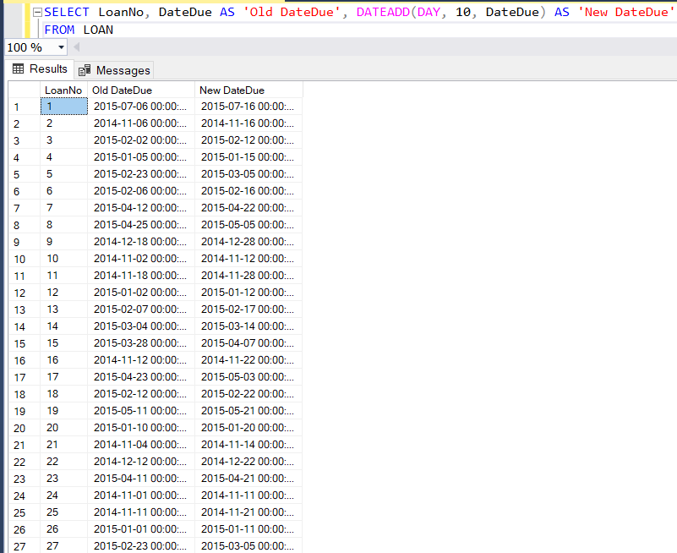

14. List all the members with their email addresses and for member without email address, display 'Email Address Not Available' in the email address column. Display the result in ascending order of Name and in the following format:

Name Email Address

……... ……………….

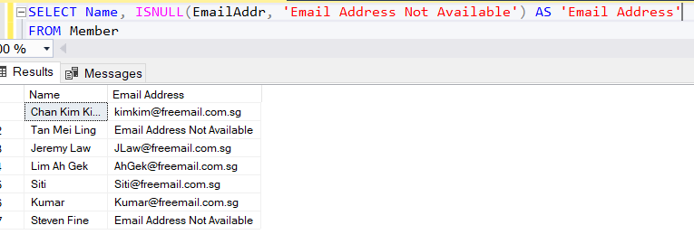

15. Rewrite the query for Practical 2 Q24 using one of the DATE functions.

List the names, addresses and contact numbers of all members who have joined before the year 2014 who have yet provided NP40Book with an email address.

### 

### **Optional**

16. List the MemberID, Name and DateJoin of members who joined NP40 Book Rental for more than a year and display the results in ascending order of DateJoin.

Hint: use DATEDIFF(), GETDATE()

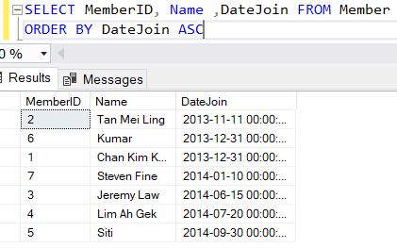

17. List the ISBN, CopyNo, Status, DateIn and 'Number of Years' for book copies that are in the store for more than 3 years and display the results in ascending order of DateIn of the book copies.

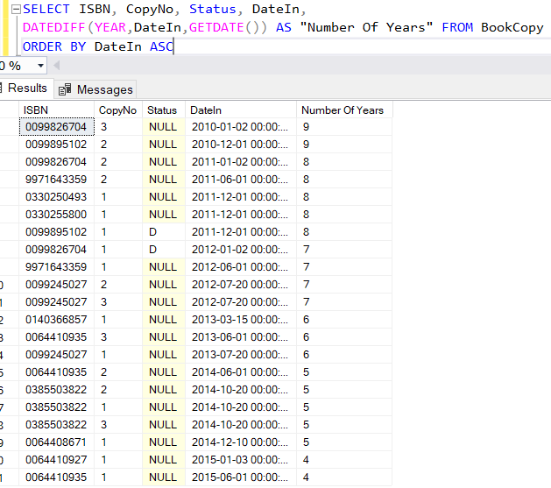

18. List the MemberID, Name and DateJoin of members who joined NP40 Book Rental in the year 2014 and display the results in ascending order of DateJoin.

Hint: use DATEPART() or DATENAME() to retrieve the year value of DateJoin

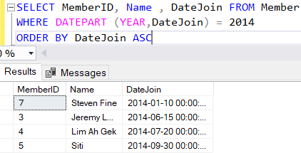

19. Find out the maximum RentalRate in *NP40 Book Store*.

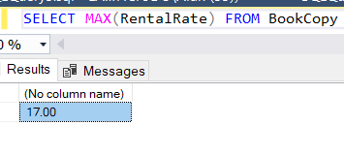

20. Find out the average rental rate in *NP40 Book Store*.

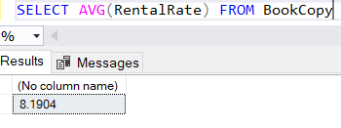

21. Find out the total ‘Number of Loan’ and the ‘Total Rental Income’ for NP40 Book Store.

Hint: use COUNT and SUM Aggregate Function

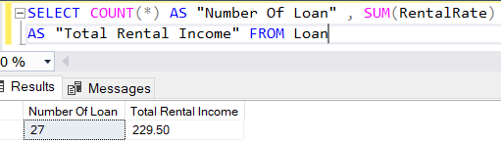

22. Display the total ‘Number of Staff’ and the ‘Total Salary Payout’.

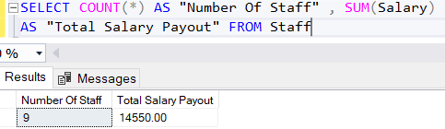

23. List the Name of all the members in upper case and in ascending order of their Name.

Hint: refer to the following link for clue on how to achieve this: <http://msdn2.microsoft.com/en-us/library/ms181984.aspx>

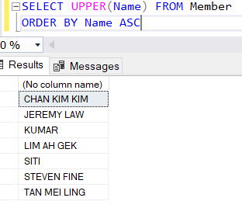

24. List the first five characters of ISBN and Title of all the books. Display the results in ascending order of the first five characters of ISBN then by Title in ascending order and in the following format.

ISBN Title

……. ……

Hint: refer to the following link for clue on how to achieve this: <http://msdn2.microsoft.com/en-us/library/ms181984.aspx>

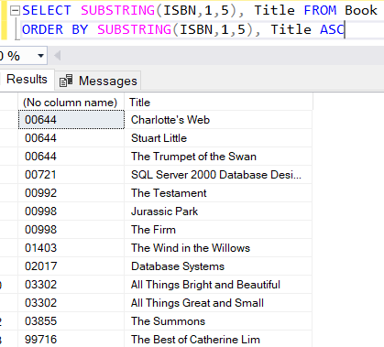

25. List the ISBN and Title of all the books by replacing the word **'**database**'** found in Title with the word **'**DB**'**. Display the result in ascending order of Title and in the following format:

ISBN Title

……. ……

Hint: refer to the following link for clue on how to achieve this: <http://msdn2.microsoft.com/en-us/library/ms181984.aspx>

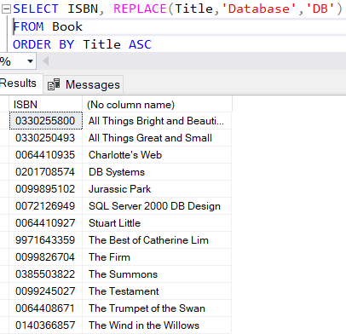

26. List the RentalRate of all the book copies and round them to the nearest integer values. Display the result in descending order of RentalRate and in the following format:

ISBN CopyNo RentalRate

……. …… ………….

Hint: refer to the following link for clue on how to achieve this: <http://msdn2.microsoft.com/en-us/library/ms177516.aspx>

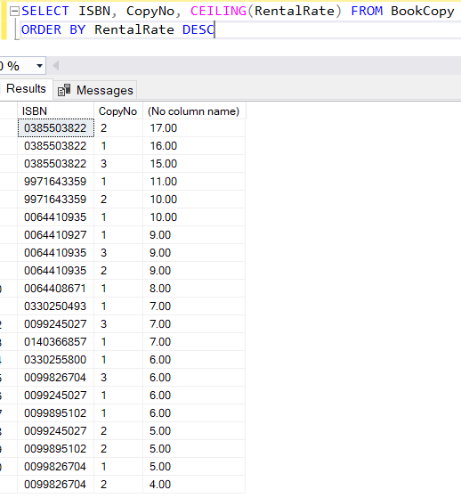

27. List the Salary of all the staff and round them to the nearest hundred. Display the result in descending order of Salary and in the following format:

StaffID Name Salary

………. …….. ……...

Hint: refer to the following link for clue on how to achieve this: <http://msdn2.microsoft.com/en-us/library/ms177516.aspx>

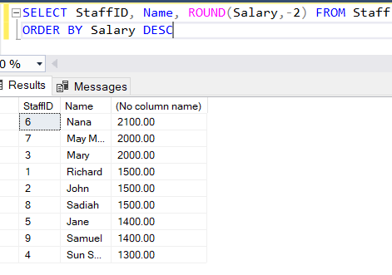

28. Display the total number of staff and the average annual salary payout.

